1.// -> to add comments
2. to save file :
any file can be saved by file>save as the extension ".sce" at the end of file name .
In clicking on Execute in the menu bar, three options are available:
- Execute "...file with no echo" (Ctrl Shift E) the file is executed without writing the program in the console.

- Execute "...file with echo" rewrite the fileinto the console and executes it.
- Execute "..until the caret,with echo"

Graphics window
to obtain an example of curve, type in console
-->plot
3) to get help for any function type --> help fn_name
4) The result of calculation that is not assigned to a variable is automatically assigned to the variable called ans.
5)function definition begins with function and end with endfunction.
e.g function d= dollars(e,t); d=e*t; endfunction
6) Matrices:
i) , is used to seprate column and semicolons(;) are used to seprate rows

7) disp fn: disp("jaj")===>jaj
TO display a combination of words and values use the string command which converts values to char strings using a "+" btw the diff parts
e.g
d=500;
disp("bob won" + string(d)+"dollars")
8) Loops:
3:10 ==> 3. 4. 5. 6. 7. 8. 9. 10.
1:2:10 ==> 1. 3. 5. 7. 9.
20:-4:2 ==> 20. 16. 12. 8. 4.
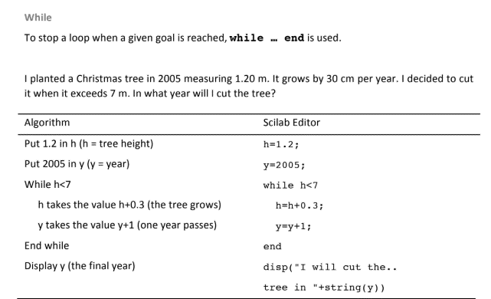

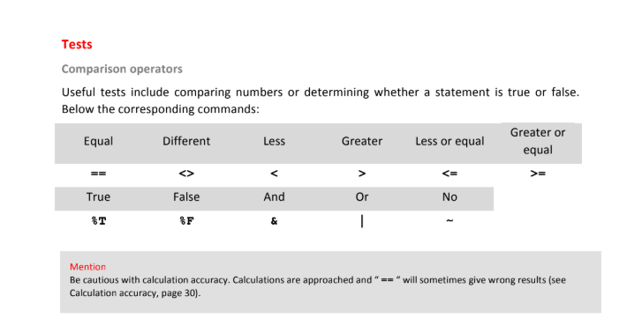

9) To compare two vectors (or matrices) , the tests “==” and “<>” will compare term by term.
10) TO test if two vectors are equal , iseqal is used and ~isequal is used if they are diff.

